AWS CLOUD PROJECT • LEARNING BRIEF

AWS Glue ETL Pipeline with Amazon S3

Prepared by: C TRISHA

1. Project overview
ETL means Extract, Transform, and Load. AWS Glue is a managed data integration service that can discover data structure, transform datasets, and write prepared data to a target. Amazon S3 commonly stores both the original raw data and the curated output.

2. Main components
- Amazon S3 raw zone: stores the original source file, such as an employee CSV.
- AWS Glue crawler: scans the source data and infers its schema, including column names and data types.
- AWS Glue Data Catalog: stores metadata in a database and table so the dataset can be discovered and reused.
- AWS Glue Studio: provides a visual interface to connect source, transformation, and target nodes.
- Transformation: the Drop Fields step removes the city column while retaining the other fields in the example pipeline.
- Curated S3 output: the job writes the transformed dataset in Parquet format with Snappy compression for analytical use.
- IAM role: provides Glue with the required permissions to read the source and write the output.

3. Pipeline workflow
Upload CSV to S3 raw folder → run Glue crawler → review the Data Catalog table → build the Visual ETL job → remove the city field → configure S3 output in Parquet/Snappy → run the job → verify curated output.

4. Validation and troubleshooting
- Confirm the crawler completed and the Data Catalog table contains the expected columns.
- Check the ETL source, transformation, and target nodes before running the job.
- If the job fails, inspect the job run details and logs, then verify IAM permissions and S3 paths.
- After a successful run, confirm that output files exist in the curated folder and that the city field is absent from the transformed schema.

5. Why this pattern is useful
Keeping raw and curated data separate preserves the original input and makes transformations easier to validate. A cataloged, columnar output such as Parquet can support downstream analytics more efficiently than repeatedly parsing raw CSV files.

What I learned
I understood how AWS Glue components work together: the crawler discovers structure, the Data Catalog stores metadata, and the ETL job transforms raw data and writes curated output to S3. A successful pipeline must be validated through both job status and the generated output.

Practical evidence to attach
Insert your own screenshots from the actual project in the spaces below. No screenshots from previous assignments have been copied into this report.
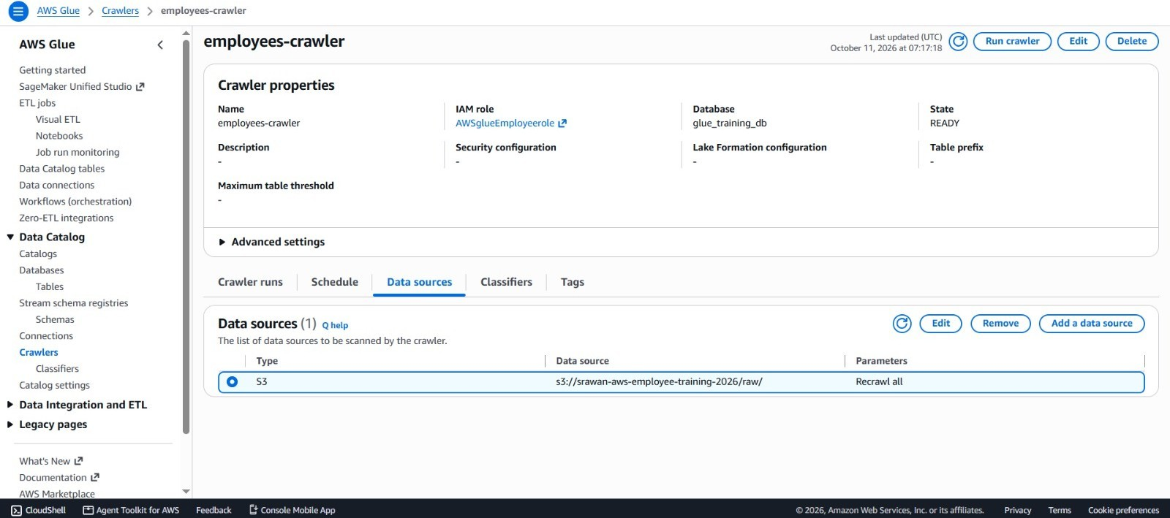
Screenshot 1: S3 raw folder containing the source CSV file.

Screenshot 2: Glue crawler run completed and the Data Catalog table/schema.
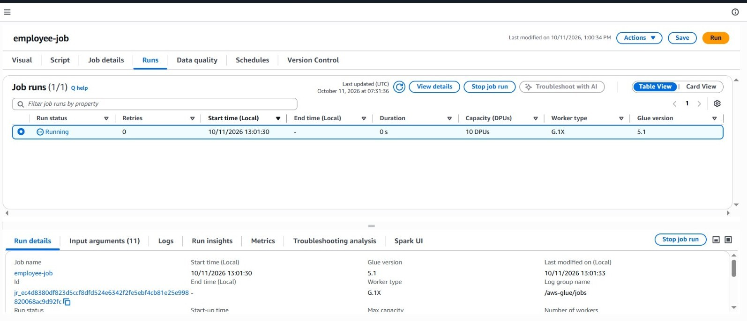
Screenshot 3: Glue Studio visual job showing source, Drop Fields transformation, and target.
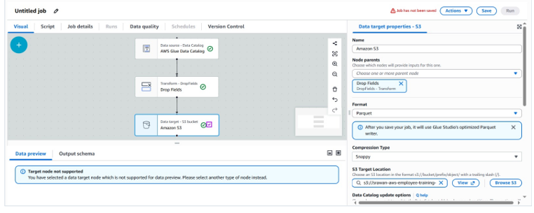
Screenshot 4: Successful Glue job run details.
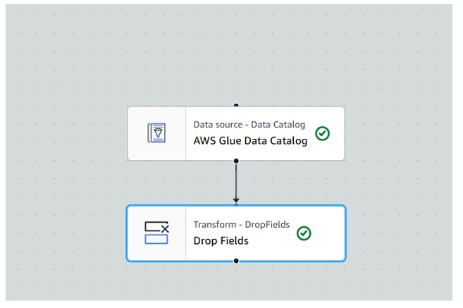
Screenshot 5: S3 curated folder showing generated Parquet output.
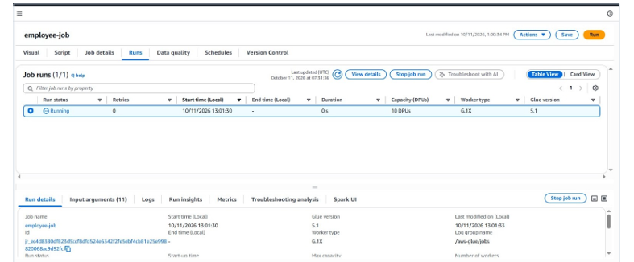

What I learned
I understood how AWS Glue components work together: the crawler discovers structure, the Data Catalog stores metadata, and the ETL job transforms raw data and writes curated output to S3. A successful pipeline must be validated through both job status and the generated output.

